Klawiter – AP World History
A Concise History of Oceania

Regional Overview/Reference Maps

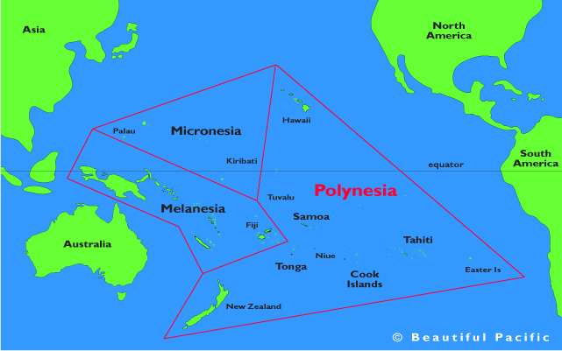

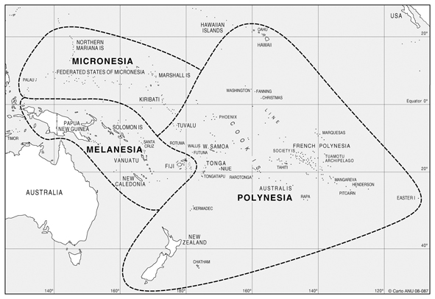
Period 1: c. 8000 BCE - 600 BCE
-Paleolithic migrations into Australia c. 60,000 years ago
-low-sea levels created land bridges, but they likely had rafts as well
-Australian settlers lived a hunting-foraging lifestyle, as did their descendants through all future eras
-Austronesian language-speaking peoples travel into the New Guinea region c. 3000 BCE from SE Asia, though
the original location is a source of fighting among historians
-double-canoe outrigger boats, could be stable on ocean
-mapped using stars, winds, currents, island landmarks
-introduced chickens, pigs, yams, taro root into New Guinea, prompted the development
of settled agriculture and specialized labor
-from New Guinea they launched the long process of finding new islands on which to settle
-through most of Melanesia by 1000 BCE and into Polynesia, with Hawaii settled by early
CE, Easter Island around 400 CE and lastly all the way back to New Zealand by 700 CE

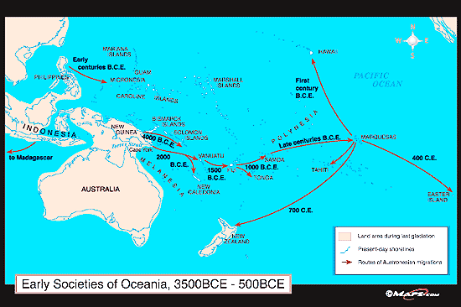

Periods 2 and 3: 600 BCE – 1450 CE
-Oceanic people spread to Polynesia, hitting Hawaii 300 CE and finally New Zealand c. 700 Ce
-eliminated much of native animal species and introduced “transported” plants and animals:
-tara, yams, bananas, breadfruit
-pigs, chickens, dogs, rats
-sweat potatoes especially important in New Zealand
-trade networks flourished between islands like Hawaii, Tahiti, and the Marquesas
-use of fire to clear forests to make room for transported plants
-some islanders maintained population control through infanticide, abortion, etc.
-sometimes they destroyed the environment and would have to relocate or face catastrophe
-For example: Easter Islanders arrived c. 400s CE
-by 1600 nearly all trees had been cut, many to create rolling logs for their statues
-resource shortages led the 7,000 inhabitants into violence, leaving only about 2,000 in the early
seventeenth century
-most societies were chiefdoms with polytheistic religious traditions

Period 4: 1450-1750
-Europeans began to crisscross the Pacific starting in the sixteenth century thanks to explorers like Magellan
-Jesuits and sailors hit some of the islands and they unknowingly brought smallpox and flu to islands like Guam in
Micronesia, leaving a death rate among indigenous peoples as high as 90%, but in general there was not an
exchange in the Pacific equivalent to that of the Atlantic system

Period 5: 1750 - 1900
-Captain Cook’s voyages were the first to cause major historical shifts in Oceania
-Cook had a “chronometer” that helped him determine longitude, which made his voyages precise, so
he could return again and again
-Cook in the late eighteenth century helped provide geographic information necessary for Europeans to
map the Pacific Ocean regions of Melanesia and Polynesia
-Cook took a deep interest in culture and customs of Hawaii, where he lost his life in an outburst of
violence between his crew and native peoples
-Such voyages brought devastating depopulation from disease transmission
-Islanders were “blackbirded,” or seized to be laborers on whaling ships or moved to cash crop fields
-Europeans brought new animals and plants and further altered the environment:
-cattle in Hawaii grew into a nuisance, trampling the earth and eating all vegetation in site
-goats were put on islands as food for traveling sailors, and they exploded in numbers
-weeds carried by Europeans thrived in this changing ecosystem
-rats were possibly the worst, which killed massive numbers of birds and ate seeds that were key for forests
-rabbits and deer tore up Australia and New Zealand
-corn, squash, and other foreign crops planted by humans eliminated indigenous crops
-whalers and sealers in New Zealand showed hardly any restraint (whale bones helped make European
corsets, oil for grease and lamps, and ambergris was used for perfume
-deforestation occurred due to the demand for timber and clearing for grazing animals like sheep
-After the American Revolution, Britain began to send its non-death-sentence criminals to the punishment of
“transportation” to penal colonies in Australia
-there they did hard labor building roads and buildings
-Australia and New Zealand became settler colonies where Brits displaced natives, who perished from conflict
and disease
-In the age of Imperialism, Pacific islands became a source of competition among European powers as they claimed
the land for coaling stations, cash crops, minerals, guano, etc.
-Indentured servants from East, South, and Southeast Asia populated cash crop and mining centers by turn of the
century
-Chinese and other migrants flooded into Australia in their Gold Rush in the 1850s/1860s, prompting
the White Australian discrimination policy, similar to the U.S. Chinese Exclusion Act
-U.S. sugar growers launched a coup against Hawaii’s Queen Liliuokalani and then orchestrated the process of
annexation, which American completed in the 1890s

Period 6: 1900 - Present
-ANZAC troops used by British against Turks in WWI
-Pearl Harbor, Dec. 7, 1940, U.S. island-hopping against Japanese forces across the Pacific
-Some Pacific islands (like Bikini atoll) were used for nuclear testing during the Cold War by U.S.
-White Australia Policy was repealed by the late twentieth century
-filming of Survivor at several of these islands.

Based on information from:
1. “Of Rats and Men: A Synoptic Environmental History of the Island Pacific” by J.R. McNeill http://www.uhpress.hawaii.edu/journals/jwh/jwh052p299.pdf

2. Traditions and Encounters by Bentley et al.

