WELCOME TO Pre AP WORLD HISTORY!
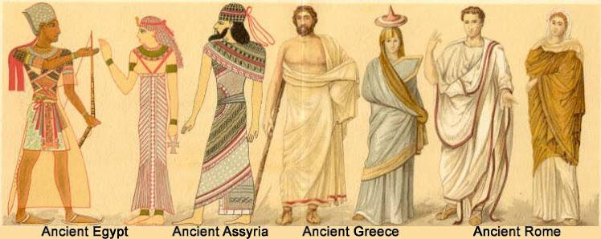
Instructor: Amanda Long
Course Website: http://mrslongsclassinfo.weebly.com/
Contact Information: along@dexter.k12.mo.us
Course Description:
The Pre-AP World History course provides a perspective and understanding of geography and history as a foundation through which students can analyze the complexities of today’s global interdependency. The course will be broken down on units of study based on historical periodization. Pre-AP World History will use the approach of analyzing global events and interactions from the foundations of history to present. The primary goal of the course is to provide a student-centered learning environment and engage the student in a comprehensive curriculum. The culminating objective is for students to demonstrate a complete picture of world history, and it is expected that students who want to take the AP exam will be prepared for that challenge. This course is broken down into two years, Pre-AP World History the first year and AP World Modern the second. This AP Exam will be taken in year 2.

Geography and World Regions Unit
- Principles of Geography
- Regionalization
- Spatial Reorganization
- Human Adaptations to the Physical Environment
- Comparison of World Regions
The Ancient Period, to c. 600 BCE
- Human Adaptation and Migration in the Paleolithic World
- Causes and Effects of Neolithic Revolution
- Origins of Complex Urban Societies in the Ancient World
- Pastoralism in Afro–Eurasia
- State Formation in Ancient Afro– Eurasia
- Development of Ancient Afro– Eurasian Religions
- Development of Ancient Afro– Eurasian Societies

The Classical Period, c. 600 BCE to c. 600 CE
- Classical Empires in East Asia
- South Asian States and Dharmic Religions
- Greek and Hellenistic States in the Classical Mediterranean
- The Classical Roman Mediterranean
- Classical Societies in Afro–Eurasia
- Trade Networks and Cultural Encounters in the Classical World
- The End of Classical Empires and Its Consequences in Afro–Eurasia

The Postclassical Period, c. 600 to c. 1450
- Early Islamic States
- Postclassical States: Byzantine Empire and European Kingdoms
- Postclassical States in East Asia
- The Mongols and the Revitalization of the Silk Roads
- Trans-Saharan Trade and the Spread of Islam in Sub-Saharan Africa
- Long-Distance Trade and Diffusion in the Indian Ocean Basin
- Postclassical Americas

The Early Modern Period, c. 1450 to c. 1750
- Origins of Iberian Maritime Exploration and Colonialism
- Columbian Exchange and Atlantic Slavery
- The Origins and Impact of the Western European Empires in the North Atlantic
- Early Modern Islamic Caliphates
- Land-Based Empires: Early Modern China and Russia
- Early Modern Religion
- Early Modern Western Society and Culture

The Modern Period, c. 1750 to c. 1914
- Causes of Atlantic Revolutions
- Effects of Atlantic Revolutions
- The First Industrial Revolution
- The Second Industrial Revolution
- Imperial Expansion in the Late 19th Century
- Reactions to Imperialism
- Consequences of Industrialization

The Contemporary Period, 1914 to the Present
- Origins and Outcomes of World War I in Global Context
- A New Age of Revolutions: Mexico, Russia, and China
- The Global Economy and the State Between the Wars
- World War II and the Origins of the Cold War
- A Global Cold War
- Foundations of Contemporary Globalization
- The Impact of Contemporary Globalization

College Board Framework for AP World History: https://pre-ap.collegeboard.org/pdf/pre-ap-world-history-cg-wr.pdf

Notes to Parents:
1. It is strongly suggested that you make sure your student has access either at home or through the public library to a computer and printer. The document set “Documents in World History” is available on my website. I do not recommend that you print the entire file (600 pages), because we will not use ALL of the documents. Students should be able to print, underline, and annotate the documents as we progress through the year. In addition, students will be required to type and submit “one-pagers” and other longer papers. I I also accept these via email and make my printer available to students before and after school and before class to print out their assignments.
2. All assignments, notes, and test reviews will be posted on in Google Classroom. Please make sure your student keeps up with all reading assignments, as it is essential to making a good grade in this course as well as receiving college credit.

3. If students choose to type their guided reading questions at home they may email me or share their document with me via a cloud (Google Drive, One Drive, Dropbox). Students will be required to turn in the work when it is due, even if they email it.

4. Academic dishonesty in any form is unacceptable. This includes, but is not limited to, copying any kind of work from another student or sharing answers with another student (collusion), plagiarism, or using any form of aid (a.k.a. cheat sheet) on a test or quiz. The testing environment is less than stellar in the classroom and the challenges and temptations are many. Nevertheless, cheating in school has become far too acceptable among many students and needs to be eliminated. If, for any reason, a student is perceived as cheating, especially during a test, the following actions will be taken:
- The assignment, quiz or test will be confiscated and will be given a grade of zero.
- The principal will be notified and a referral will be written and submitted for the record.

5. Please encourage your student and keep them motivated! This is a pivotal year for them in so many ways – they may learn to drive, date, and have new interests. I hate to be dramatic about it, but this is a very pivotal year for them scholastically. They either make the commitment to academics and being a real student (one who studies) or not. It’s not easy, but it is essential to their future.

6. World History is about the good, the bad and the ugly. Be prepared to discuss historical concepts and events at home. We will cover the history of many topics from the beginning of religion, trade, foundations of civilizations, war and many more. This will add positively to your student’s experience in Pre-AP World History and increase their understanding of the relevance of history to current events.

7. Please feel free to contact me! Email works best because I receive my work email on my phone and can respond quickly.
Tutoring Times: I am available before school from 7:45-8:05 a.m. and afterschool by appointment.

I look forward to a great year!

Please fill in the information below:
I have read and understood the Course Syllabus for AP World History. I will return this to Mrs. Long by the end of the first week. I understand the syllabus will remain in my AP World History notebook for the entire school year and that a copy is available on the teacher’s website

_________________________________ __________________________________
Student’s Signature Parent’s/Guardian’s Signature

_________________________________ __________________________________
Student’s Printed Name Parent’s/Guardian’s Printed Name

_________________________________ __________________________________
Student’s E-mail Address Parent’s/Guardian’s E-mail Address

