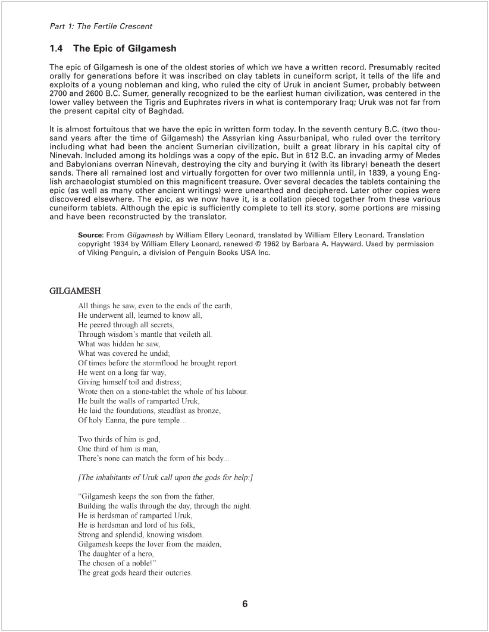

Machine generated alternative text:
Part 7: The Fertile Crescent 
The gods Of heaven called the lord Anti. 
"Was he not Of thy making, this almighty wild bull 
This hero Gilgamesh? 
HC hath not his like in the whole land 
Gilgamesh keeps the son from the father 
Building the walls through the day, through the night. 
He is herdsman of ramparted Uruk 
He is herdsman and ord of his folk 
Strong and splendid 
Knowing Wisdom 
Gilgamesh keeps the lover from the maiden 
The daughter of a hero, 
The chosen of a noble!" 
The great god Anu lent ear to their cries 
Aruru was summoned, she the great goddess: 
"Thou, Arum, madest Gilgamesh, 
Now make another like unto him. 
so long as he pleases 
Let 1-11m come at Gi gamesh. 
Let them contend together, 
That Uruk may have peace. 
As Aruru this heard, 
She shaped in her heart a warrior ofAnu. 
Aruru washed her hands, 
She pinched up some clay and spat on it 
She moulded Engidu, 
Fashioned a hero, a glorious scion, 
A fighter of Ninurta's. 
His whole body was shaggy with hair, 
Harr he bore on his head like a woman, 
The plenty of his hatr sprouted like grain. 
Ile knew naught of land and people, 
He was clothed like the god of the herds. 
With the gazelles he eats the plants, 
With the wild beasts he drinks at the watering-place, 
With the throng at the water he makes glad his heart 
He walked to the watertng-place 
Toward a hunter, a stalker Of wild beasts; 
On one day, on a second, and a third, 
Toward the hunter he walked to the watering-place. 
The hunter saw him, the hunter's face grew troubled. 
Without his quarry he turned back to his house 
He was down-cast, troubled; he shrieked 
HIS heart was afraid and his was dark 
Grief made way Into his heart, 
And he looked like a wanderer Of far ways 
(The hunterl started on the way, he entered into Uruk 
He goes to Gilgamesh, and to him he says: 
"A man that came from the hills 
Hath become strong indeed In the land 
Mighty In power like a fighter of Anu's. 
Ever he goeth along on the hills, 

Machine generated alternative text:
Part 7: The Fertile Crescent 
He is ever beside the Wild beasts, 
Ever are his feet at the watering-place 
I am afraid, I cannot go near to hilli 
HC hatll filled my pits which I dug; 
My traps which I laid 
HC hath destroyed 
So from my hands he let my quarry get away, 
The throngs of the fields, 
No catch he allows me. 
Gilgamesh says to him, to the hunter. 
"Go, my hunter, and get thee a priestess, 
When the wild beasts come to the watering-place, 
Then let her cast her garment off, 
That he may take his fill of her 
When he sees her, he will draw near, 
Then will he become a stranger to his wild beasts, 
Who on his own steppes grew up with him. " 
The hunter went yonder and got him a priestess. 
They made themselves ready, went forth straight on. 
On the third day they came to their goal 
The hunter and the priestess sat themselves down 
One day, a second day, they sat by the watering-place. 
The wild beasts come along and drink at the watering-place. 
Glad is the throng of the flood 
So too comes he, Engidu 
With the gazelles he eats the plants, 
With, the beasts he drinks at the watering-place, 
His heart is happy with the throng of the flood 
Then the priestess saw him, the great strong one, 
The Wild fellow, the man of the steppes. 
"There he is, woman' 
Loosen thy buckle, 
Unveil thy delight, 
That he may take his fill of thee' 
Hang not back, take up his lust! 
When he sees Ihee, he Will draw near 
Open thy robe that he rest upon thee! 
Arouse in htm rapture, the work of woman. 
Then will he become a stranger to his wild beasts, 
Who on his own steppes grew up with hilli 
HIS bosom wi I press against thee" 
Then the priestess oosened her buckle, 
Unveiled her delight, 
For him to take his fill Of her 
She hung not back, she took up his lust, 
She opened her robe that he rest upon her. 
She aroused in him rapture, the work of woman. 
His bosom pressed against her 
Eng'du forgot where he was born 
For six days and seven nights 
Was Engidu given over to love with the priestess 
When he had sated himself with the fi I of her 
He raised up his face to his wild ones 

Machine generated alternative text:
Part 7: The Fertile Crescent 
At sight Of Engidu, the gazelles flee away, 
The wild Of the fields shrink back before him 
Then Engidu marvelled, 
His body stood In a spell, 
His knees quivered, because his wild ran Off, 
The speed of his onset is not what it was_ 
He hearkens and opens his ear: 
He turns about and Sits down at the feet of the priestess. 
He looks the priestess in the face, 
And to what the priestess now speaks 
His ears give heed 
The priestess says to him, to Engidu, 
"Engidu, how beautiful thou, how like a god! 
Why must thou rush with animals over the steppes? 
Come, I will lead thee into ramparted Uruk 
TO a pure house, the dwelling of Anu and Ishtar 
Where Gilgamesh lives, matchless in might, 
And like a wild bull lords it over the folk.. 
She talks to him, till he likes her words 
Knowing his own heart, he seeketh a friend. 
Engldu says to her, to the priestess: 
"Woman, go to! Lead me to the pure, the holy house, 
The dwelling of Anu and Ishtar, 
Where Gilgamesh lives, matchless in might, 
And like a wild bull lords it over the folk. 
I will challenge him to a fight 
I will call the strong one. 
I will call out in Uruk 
'I too am a strong one" 
I alone can alter fate, 
I, born on the steppes, matchless in might 
O Gilgamesh, may I behold thy face! 
Well I know what the outcome will be ' 
Engldu goes along the market-street 
Of ramparted Uruk 
Marvelling he looks at the mighty work; 
He bars the way Of the warriors Of Uruk; 
Then the folk Of Uruk crowd against him, 
The land IS assembled 
But in fear the folk turn away 
They fall dowrL . like a weak child 
The couch had been spread Ibr goddess Ishtar. 
At the gates of her house 
Engldu barred the going-to, 
Allowed not Gilgamesh that he enter in, 
They grappled each other at the gates of her house, 
They fought in the street 
That the doorposts quaked and the wall swayed 
Gilgamesh crumpled his leg to the ground 
His anger softened he checked his onset, 
When he had checked his onset, Says Fngidu to him 
to Gi gamesh 

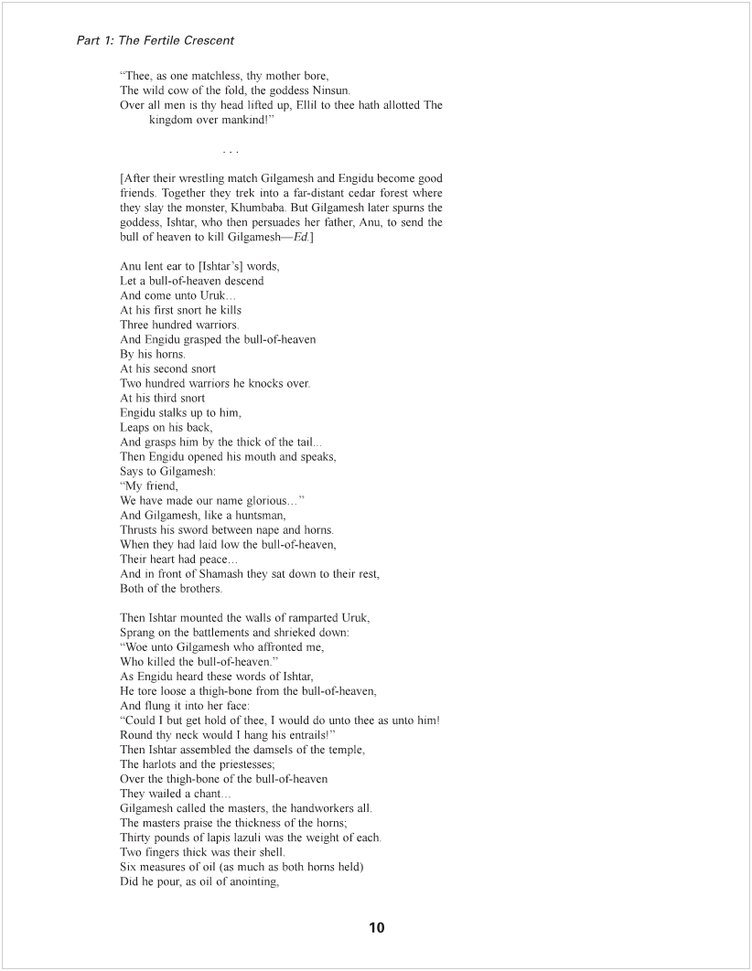

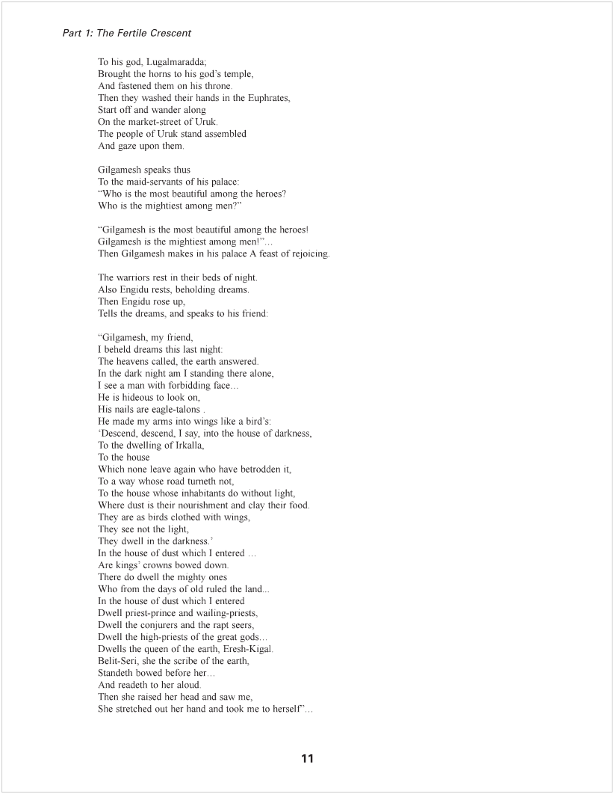

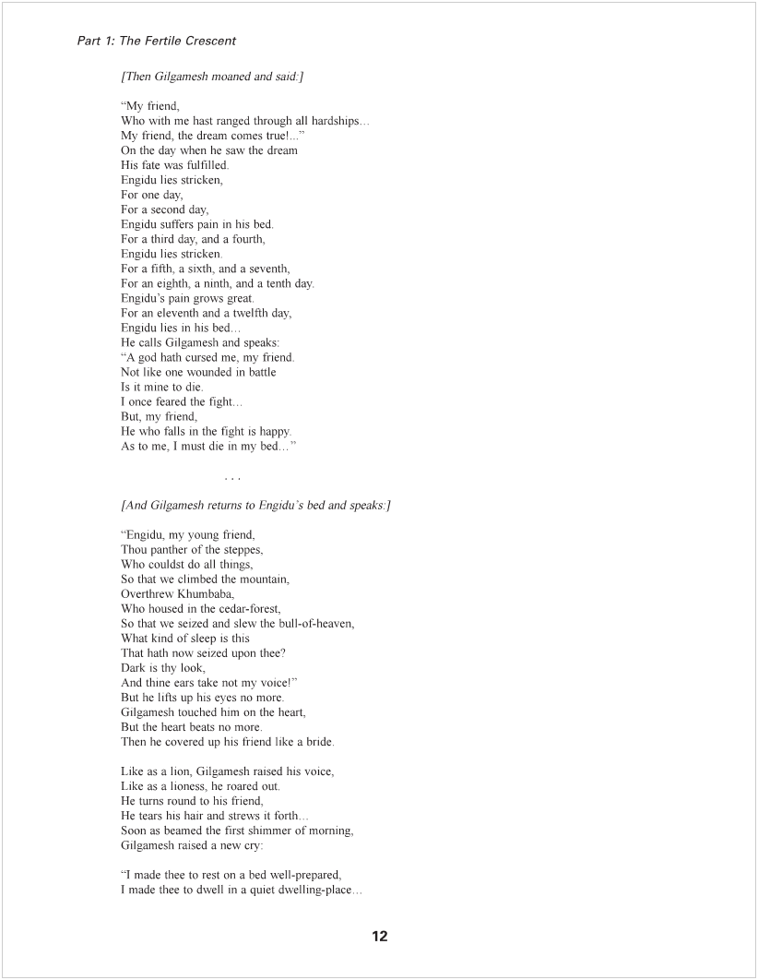

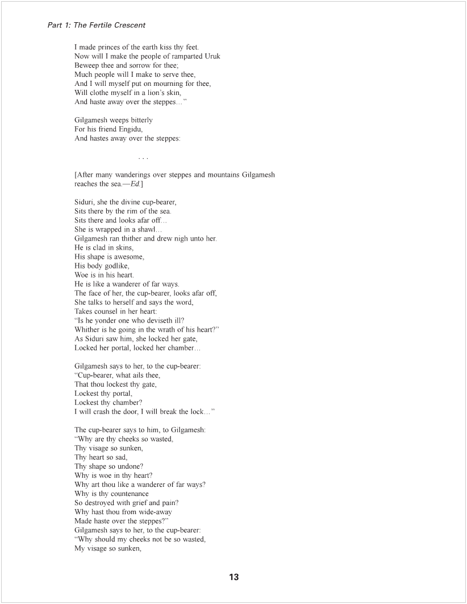

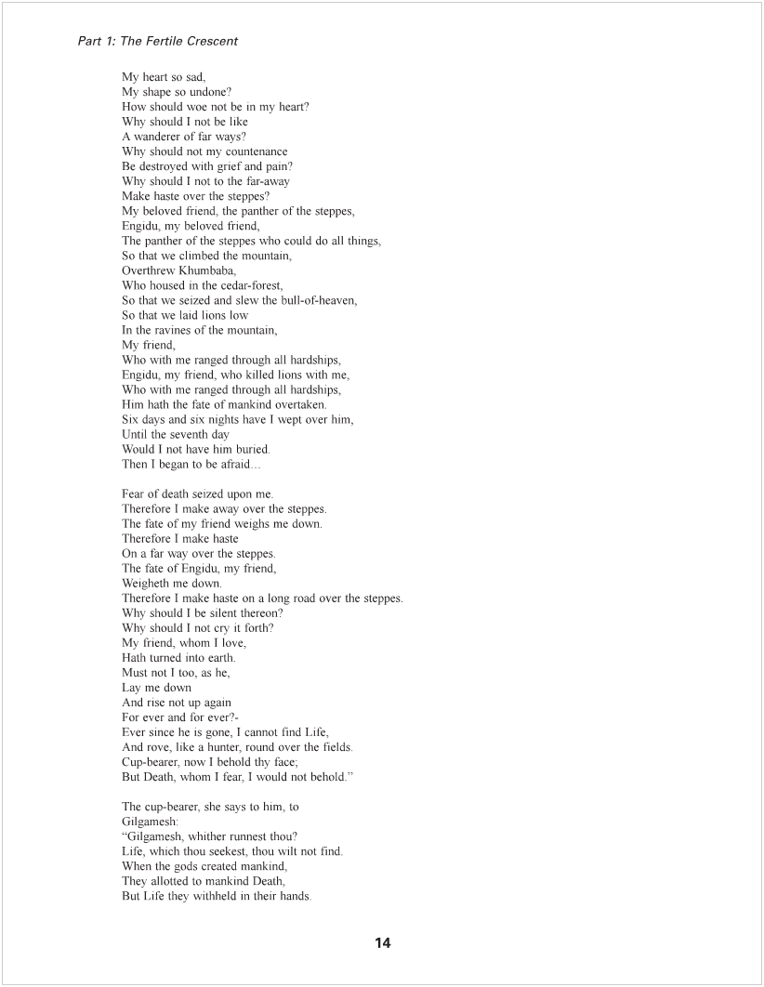

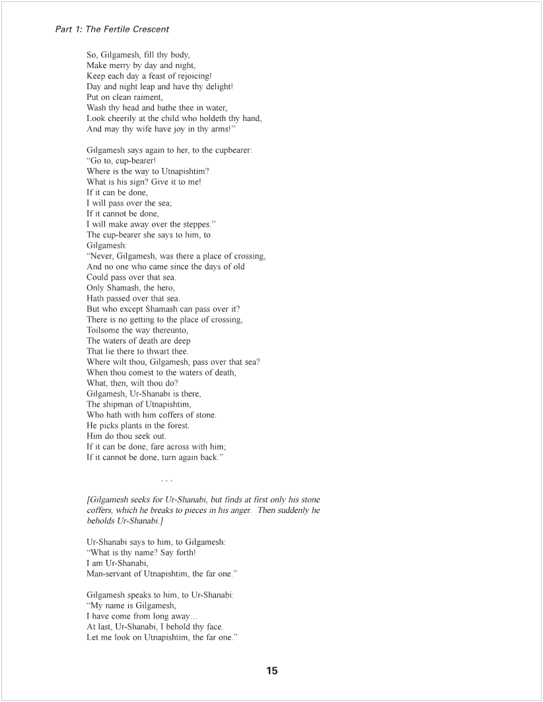

Machine generated alternative text:
Part 7: The Fertile Crescent 
And Gilgamesh says again to him, 
TO Ur-Shanab' the shipman: 
"Come, Ur-Shanabi, where 's the way to Utnapishtim? 
What is his sign? Give It to me' 
Give me, give me his sign! 
If it can be done, 
I will pass over the sea; 
If it cannot be done, 
I will make away over the steppes," 
Ur-Shanabi says to h m, to Gi gameslv 
"Thy hands, O Gilgamesh 
Have hindered a landing, 
Thou brakest to pieces the coffers of stone, 
The coffers of stone are to-broken; 
And so I cannot ferry thee over 
Gilgamesh, take the axe in thy arm, 
GO down to the forest, 
Cut poles of length sixty ells, 
Smear them with pitch and bear them to me. 
As Gilgamesh this heard, 
He took the axe in his arm, 
Drew the sword from his girdle, 
Went down to the forest, 
And cut poles of length sixty ells, 
Smeared them with pitch. _ 
And brought them to Ur-Shanabi. 
Gilgamesh and Ur-Shanabi boarded the ship, 
They headed the ship into the flood, 
And sailed forth, 
A way of one month and fifteen days. 
As he took his bearings on the third day, 
Ur-Shanab1 had reached the waters of death. 
Ur-Shanabl says to him, to Gilgamesh: 
"Quick, Gilgamesh, take a pole' 
For thy hands must not Louch 
The waters Of death 
A second, a third, a fourth pole, 
Take, Gilgamesh' 
An fifth, a sixth, a scwenth pole, 
Take, Gilgamesh' 
An eighth, a ninth, a tenth pole, 
Take, Gilgamesh' 
An eleventh, a twelfth pole, 
Take, Gilgamesh"' 
At a hundred and twenty 
Gilgamesh had used up the poles, 
Now he made his hips free 
Gilgamesh stripped off his garment, 
And with his hands made high the mast, 
Utnapishtim descrieth his face afar, 
Talks to himself and saith the word, 

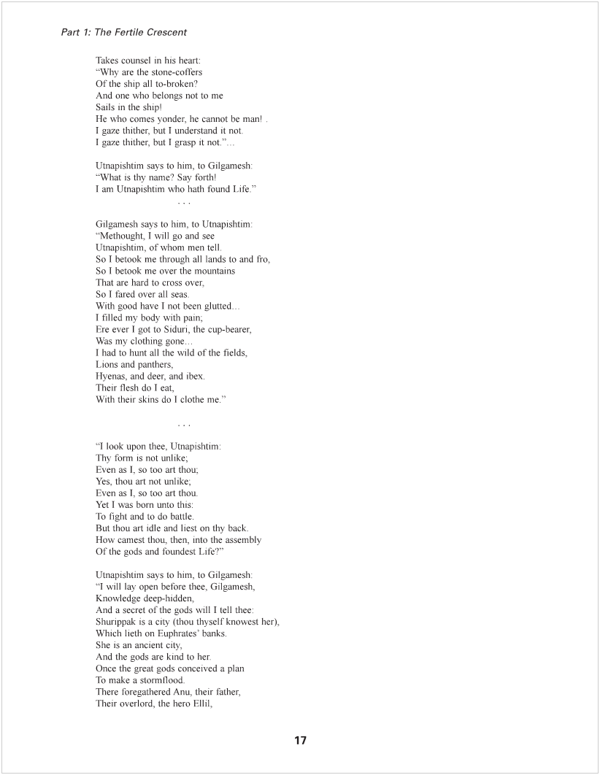

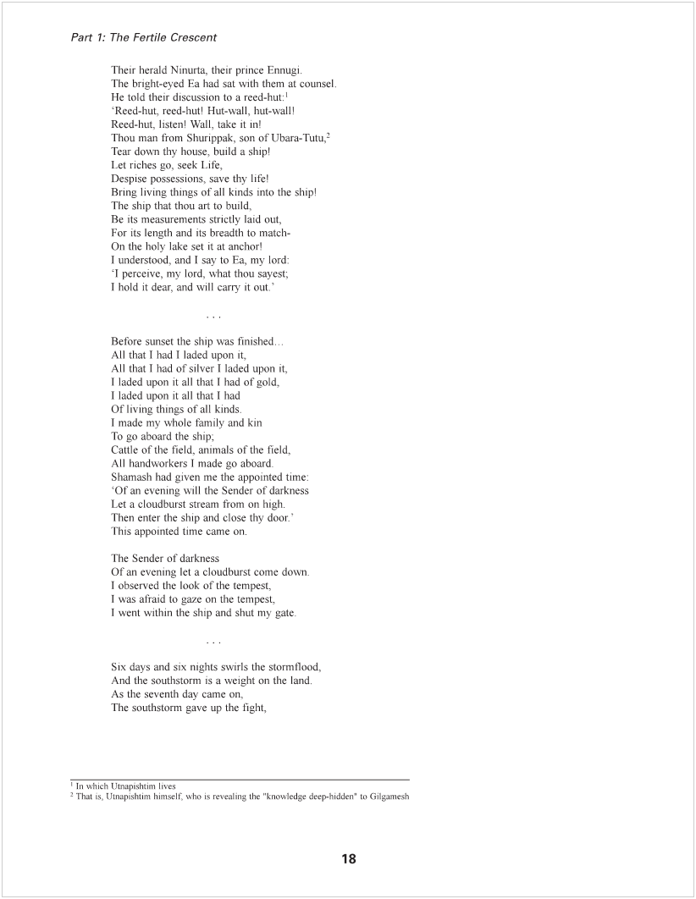

Machine generated alternative text:
Part 7: The Fertile Crescent 
Which it had fought like an army. 
The sea grew quiet, and gathered up its waters, 
The stormflood ceased 
I looked for the tempest, all had become still 
The who e racc Of man was turned to earth, 
Like a flat roof were the plains, 
Then I opened a hatch 
And light streamed into my face, 
I sat me down weeping, 
And my tears ran over my face 
I gazed about for solid earth 
In the dominions of the sea. 
After twelve hours an island emerged 
The ship drove for Mount Nlssrr, 
Mount Nissir holds the ship fast 
And keeps it from rocking. 
One day, a second day, Mount Nissir 
Holds the ship fast and keeps it from rocking. 
A third and fourth day Mount Nissir 
Holds the ship fast and keeps it from rocking. 
A fifth, a sixth day Mount Nissir 
Holds the ship fast and keeps it from rocking. 
"As the seventh day came on, 
I held a dove outside and set it free 
The dove flew forth and came back. 
She found no resting-place, so she turned home. 
I held a swallow outside and set iffree' 
The sv,allow flew forth and came back 
She found no resting-place, so she turned home. 
I held a raven outside and set it free; 
The raven flew forth, saw the water run dry, 
He feeds, scrapes, croaks, and turned not home. 
Then I let all out unto the four winds, 
And offered a sacrifice, 
Set up a burnt-offering 
On the top of the mountain 
Gilgamesh and Ur-Shanabi boarded the ship, 
They headed the ship into the 1100d, 
And sailed away. 
Then said his wife to him, 
TO Utnap'shtim, the far one: 
"Gilgamesh bath set forth; 
HC hath worn himself out, and suffered torments. 
What wilt thou give him 
That with it he may reach his homeland?" 
And Gilgamesh has already lifted the pole, 
And brings the ship again near the shore 
Utuapishtim says to him, to Gilgamesh 
"Gilgamesh, thou hast set forth- 
Thou hast worn thyself out, and suffered torments. 

Machine generated alternative text:
Part 7: The Fertile Crescent 
What shall I give thee 
That with it thou reachest thy homeland? 
I will lay open before thee 
Knowledge deep-hidden; 
About a plant of life will I tell thec 
The plant looks like the prick-thorn 
Its thorn like the thorn of the rose 
Can prick the hand hard 
When thou gettest this plant in thy hands, 
Eat thereof and thou wilt live, 
When Gilgamesh learned of this, 
He bound heavy stones on his feet; 
These drew him down deep in the sea, 
He himself took the plant, 
And it pricked his hand hard 
He cut off the heavy stones. 
And laid the plant beside him. 
Gilgamesh says to him, 
To Ur-Shanabi, the shipman: 
"Ur-Shanabi, this plant 
Is a plant-of-promise, 
Whereby a man obtains his desire. 
I will bring it to ramparted Uruk; 
I will make the warriors eat thereof. 
Its name is: 'The-old man-becomes-young-again. 
I myself Will eat thereof, 
And return back to my youth' 
After twenty miles they took a little food, 
After thirty miles they rested for the night. 
Then Gilgamesh saw a pit with cool water; 
Ile stepped Into it and bathed in the water. 
Then a serpent savoured the smell of the plant; 
She crept along and took the plant 
When he returned, he shrieked out a curse. 
Gilgamesh sat himself down and weeps, 
HIS tears run over his face. 
He speaks and says to Ur-Shanabi, the shipman: 
"For whom, Ur-Shanabi, 
Have my arms worn themselves Out? 
For whom hath been spent the blood Of my heart? 
I worked good not for myself- 
For the worm Of the earth have I wrought good 
Questions: 
l. What are Gilgamesh's virtues? What are his faults? What does this tell us about the values and 
assumptions of the community that produced and preserved this story? 
2. What does this story teach us about human nature and the human condition? What does it teach 
us about the nature Of gods and their relationship With humans? 